# Section 4

## Collaborate Results

### Lab 4.1 - Share Web App and Model API

Congratulations! You have now gone through a full workflow to pull data from an S3 bucket, clean and visualize the data, train several models across different frameworks, deploy the best-performing model, and use a web app front end to easily score your model. Now, the final step is to get your model and front end into the hands of the end users.

From the App page, navigate to the **Permissions** tab.

In the permissions tab, update the permissions to allow anyone, including anonymous users.

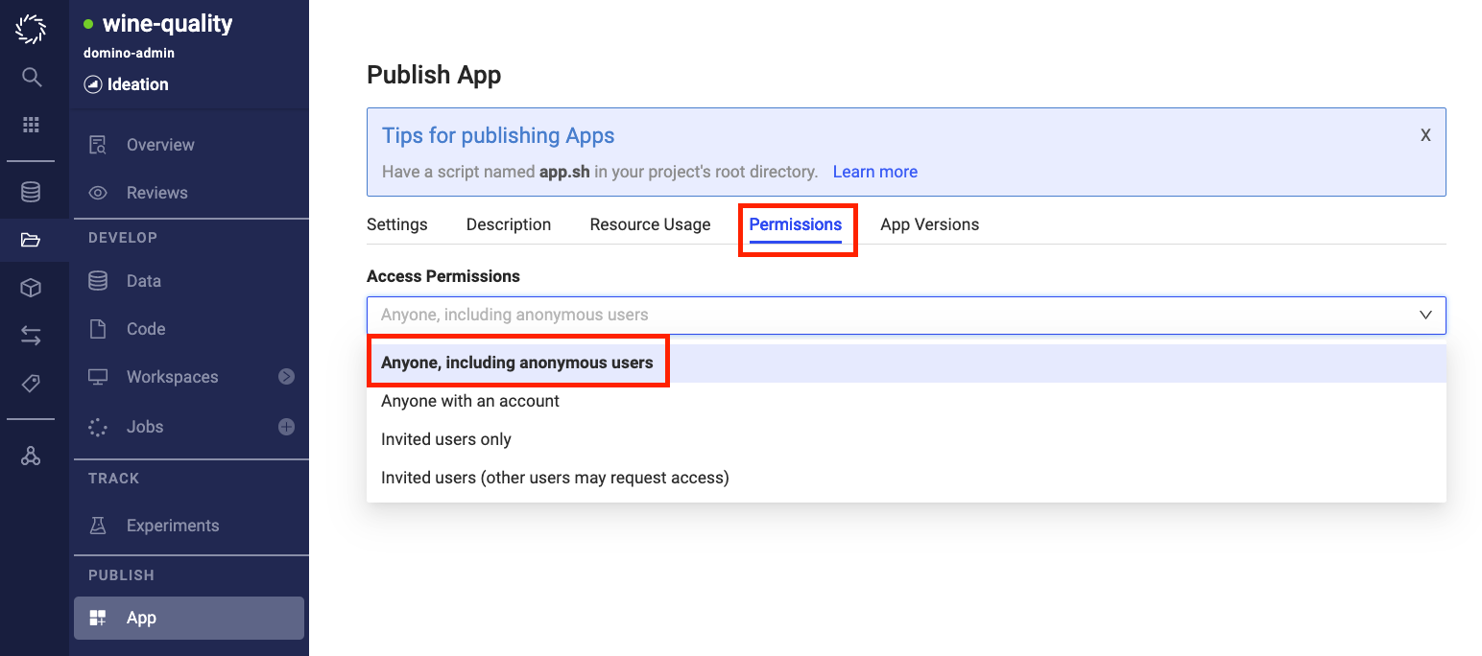

Navigate back to the **settings** tab and click **Copy Link App.**

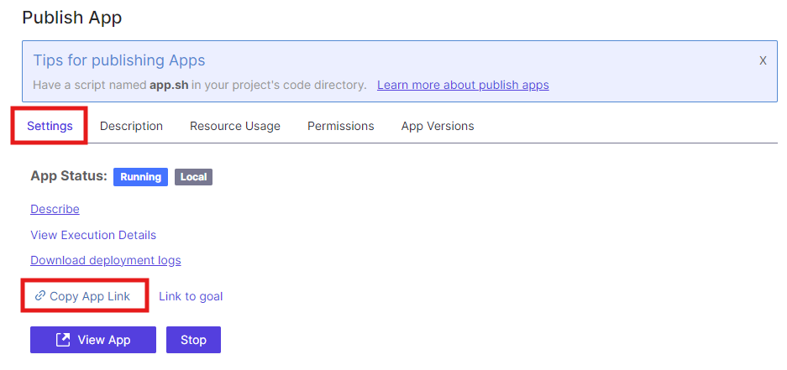

Paste the copied link into a new private or incognito window. You can view the app without being logged into Domino.

Domino provides free licenses for business users to log in, view models/apps, etc.

**End of Workshop**